# BANK LOAN REPORT QUERY DOCUMENT

1. **BANK LOAN REPORT | SUMMARY**

## **KPI’s:**

**Total Loan Applications**

**SELECT COUNT(id) AS Total_loan_application FROM bank_loan_data;**



**MTD Loan Applications**

**SELECT COUNT(id) AS MTD_Total_Loan_Applications FROM bank_loan_data**

**WHERE MONTH(issue_date)=(SELECT MAX(MONTH(issue_date)) from bank_loan_data)**

**AND YEAR(issue_date)= (SELECT MAX(YEAR(issue_date)) from bank_loan_data);**



**PMTD Loan Applications**

**SELECT COUNT(id) AS PMTD_Total_Loan_Applications FROM bank_loan_data**

**WHERE MONTH(issue_date)=(SELECT MAX(MONTH(issue_date)) from bank_loan_data) -1**

**AND YEAR(issue_date)= (SELECT MAX(YEAR(issue_date)) from bank_loan_data);**



**Total Funded Amount**

**SELECT SUM(loan_amount) as Total_funded_amount FROM bank_loan_data;**



**MTD Total Funded Amount**

**SELECT SUM(loan_amount) as MTD_Total_funded_amount FROM bank_loan_data**

**WHERE MONTH(issue_date)=12 AND YEAR(issue_date)=2021;**



**PMTD Total Funded Amount**

**SELECT SUM(loan_amount) as PMTD_Total_funded_amount FROM bank_loan_data**

**WHERE MONTH(issue_date)=11 AND YEAR(issue_date)=2021;**



**Total Amount Received**

**SELECT SUM(total_payment) as Total_Amount_Received FROM bank_loan_data;**



**MTD Total Amount Received**

**SELECT SUM(total_payment) as MTD_Total_Amount_Received FROM bank_loan_data**

**WHERE MONTH(issue_date)=12 AND YEAR(issue_date)=2021;**



**PMTD Total Amount Received**

**SELECT SUM(total_payment) as PMTD_Total_Amount_Received FROM bank_loan_data**

**WHERE MONTH(issue_date)=11 AND YEAR(issue_date)=2021;**



**Average Interest Rate**

**SELECT AVG(int_rate)*100 AS Avg_Interest_Rate FROM bank_loan_data;**



**MTD Average Interest Rate**

**SELECT AVG(int_rate)*100 AS MTD_Avg_Interest_Rate FROM bank_loan_data**

**WHERE MONTH(issue_date)=12 AND YEAR(issue_date)=2021;**



**PMTD Average Interest Rate**

**SELECT AVG(int_rate)*100 AS PMTD_Avg_Interest_Rate FROM bank_loan_data**

**WHERE MONTH(issue_date)=11 AND YEAR(issue_date)=2021;**



**Avg DTI**

**SELECT AVG(dti)*100 AS Avg_DTI FROM bank_loan_data;**



**MTD Avg DTI**

**SELECT AVG(dti)*100 AS MTD_Avg_DTI FROM bank_loan_data**

**WHERE MONTH(issue_date) = 12 AND YEAR(issue_date)=2021;**



**PMTD Avg DTI**

**SELECT AVG(dti)*100 AS PMTD_Avg_DTI FROM bank_loan_data**

**WHERE MONTH(issue_date) = 11 AND YEAR(issue_date)=2021;**



**GOOD LOAN ISSUED**

**Good Loan Percentage**

**SELECT**

**(COUNT(CASE WHEN loan_status="Fully Paid" OR loan_status="Current" THEN id END)*100)**

**/**

**COUNT(id) AS Good_loan_percentage**

**FROM bank_loan_data;**



**Good Loan Applications**

**SELECT COUNT(id) AS Good_Loan_Applications FROM bank_loan_data**

**WHERE loan_status="Fully Paid" OR loan_status="Current";**



**Good Loan Funded Amount**

**SELECT SUM(loan_amount) AS Good_Loan_Funded_amount FROM bank_loan_data**

**WHERE loan_status = 'Fully Paid' OR loan_status = 'Current';**



**Good Loan Amount Received**

**SELECT SUM(total_payment) AS Good_Loan_amount_received FROM bank_loan_data**

**WHERE loan_status = 'Fully Paid' OR loan_status = 'Current';**



**BAD LOAN ISSUED**

**Bad Loan Percentage**

**SELECT**

**(COUNT(CASE WHEN loan_status="Charged Off" THEN id END)*100)**

**/**

**COUNT(id) AS Bad_loan_percentage**

**FROM bank_loan_data;**



**Bad Loan Applications**

**SELECT COUNT(id) AS Bad_Loan_Applications FROM bank_loan_data**

**WHERE loan_status="Charged Off";**



**Bad Loan Funded Amount**

**SELECT SUM(loan_amount) AS Bad_Loan_Funded_amount FROM bank_loan_data**

**WHERE loan_status = 'Charged Off';**



**Bad Loan Amount Received**

**SELECT SUM(total_payment) AS Bad_Loan_amount_received FROM bank_loan_data**

**WHERE loan_status = 'Charged Off';**



**LOAN STATUS**

**SELECT**

**loan_status,**

**COUNT(id) AS Loan_Count,**

**SUM(total_payment) AS Total_amount_received,**

**SUM(loan_amount) AS Total_funded_amount,**

**AVG(int_rate)*100 AS Interest_rate,**

**AVG(dti)*100 AS DTI**

**FROM bank_loan_data**

**GROUP BY loan_status;**

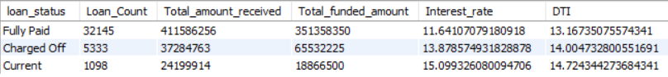

**SELECT**

**loan_status,**

**SUM(total_payment) AS MTD_Total_Amount_Received,**

**SUM(loan_amount) AS MTD_Total_Funded_Amount**

**FROM bank_loan_data**

**WHERE MONTH(issue_date) = 12**

**GROUP BY loan_status;**

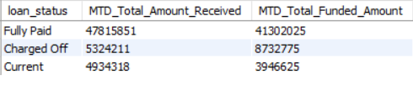

1. **BANK LOAN REPORT | OVERVIEW**

**MONTH**

**SELECT**

**MONTH(issue_date) as Month_Number,**

**MONTHNAME(issue_date) AS Month_Name,**

**COUNT(id) AS Total_Loan_Applications,**

**SUM(loan_amount) AS Total_Funded_Amount,**

**SUM(total_payment) AS Total_Received_Amount**

**FROM bank_loan_data**

**GROUP BY MONTH(issue_date),MONTHNAME(issue_date)**

**ORDER BY MONTH(issue_date);**

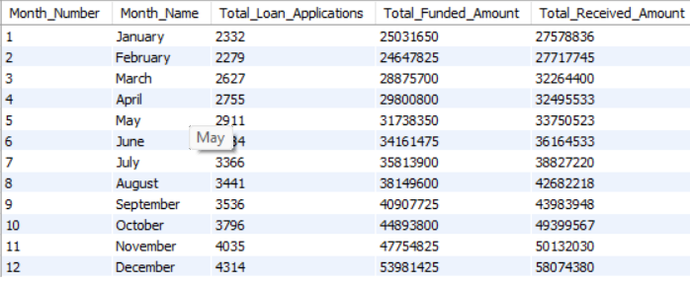

**STATE**

**SELECT**

**address_state as State,**

**COUNT(id) AS Total_Loan_Applications,**

**SUM(loan_amount) AS Total_Funded_Amount,**

**SUM(total_payment) AS Total_Received_Amount**

**FROM bank_loan_data**

**GROUP BY address_state**

**ORDER BY address_state;**

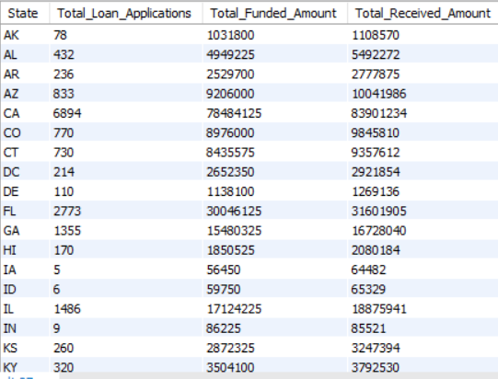

**TERM**

**SELECT**

**term,**

**COUNT(id) AS Total_Loan_Applications,**

**SUM(loan_amount) AS Total_Funded_Amount,**

**SUM(total_payment) AS Total_Received_Amount**

**FROM bank_loan_data**

**GROUP BY term**

**ORDER BY term;**

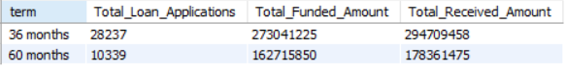

**EMPLOYEE LENGTH**

**SELECT**

**emp_length AS Employee_Length,**

**COUNT(id) AS Total_Loan_Applications,**

**SUM(loan_amount) AS Total_Funded_Amount,**

**SUM(total_payment) AS Total_Received_Amount**

**FROM bank_loan_data**

**GROUP BY emp_length**

**ORDER BY emp_length;**

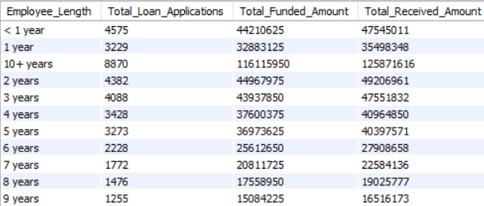

**PURPOSE**

**SELECT**

**purpose AS PURPOSE,**

**COUNT(id) AS Total_Loan_Applications,**

**SUM(loan_amount) AS Total_Funded_Amount,**

**SUM(total_payment) AS Total_Amount_Received**

**FROM bank_loan_data**

**GROUP BY purpose**

**ORDER BY purpose;**

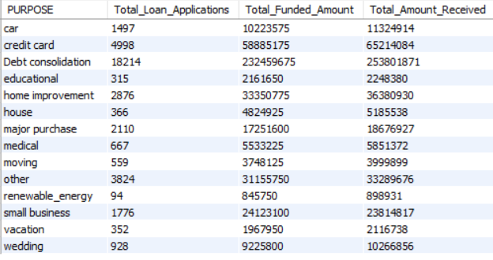

**HOME OWNERSHIP**

**SELECT**

**home_ownership AS Home_Ownership,**

**COUNT(id) AS Total_Loan_Applications,**

**SUM(loan_amount) AS Total_Funded_Amount,**

**SUM(total_payment) AS Total_Amount_Received**

**FROM bank_loan_data**

**GROUP BY home_ownership**

**ORDER BY home_ownership;**

